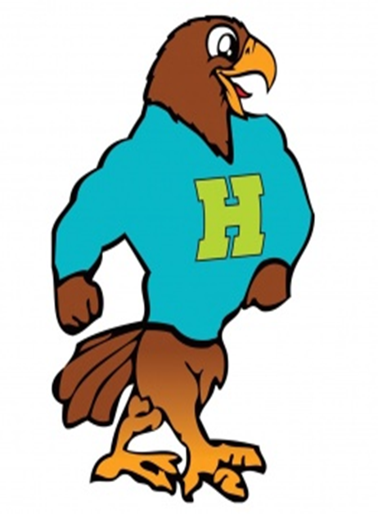

**Herbert Akins Road Elementary**

**Third Grade Supply List 2024 - 2025**

|  |  |  |
| --- | --- | --- |
| Item | Amount Needed | Notes |
| Wide-ruled composition notebook | 1 | No spiral notebooks |
| Plastic pocket folders **WITH** prongs | 4 | 1- Green  1- Blue  1- Purple  1- Yellow  **(please only get these colors)** |
| Crayola Crayons or Colored pencils | 1 pack | Crayons- pack of 24 or less  Colored pencils- pack of 10 |
| Pencils | 1 pack | Ticonderoga preferred  (they last longer, sharpen better, and erase better) |
| Earbuds/headphones | 1 | Will be kept at school |
| Pencil box | 1 | Hard, sturdy box that will be large enough to fit supplies |
| Child sized scissors  (left handed children need left handed scissors) | 1 pair | Blunt tip- Fiskar preferred |
| Glue Sticks | 12 sticks | Standard size preferred (not jumbo) |
| Expo Dry Erase Markers | 1 pack |  |
| Tissues | 1-2 boxes |  |

**\*\*Individual teachers may request additional supplies to support learning in their classroom. Please check in with your teacher at our Meet the Teacher event in July. Feel free to bring supplies to the Meet the Teacher event. \*\***

**Supplies by Track**

|  |  |
| --- | --- |
| Track 1- 1 pack pink pearl erasers, computer mouse (kept by student), 1 pack of wide-ruled notebook paper | Track 3- 1 pack of pencil top erasers, 1 box of sandwich sized ziplock bags, sticky notes |
| Track 2- 1 pack pink pearl erasers, 1 package of 20 sheet protectors | Track 4- 1 container of disinfecting wipes |